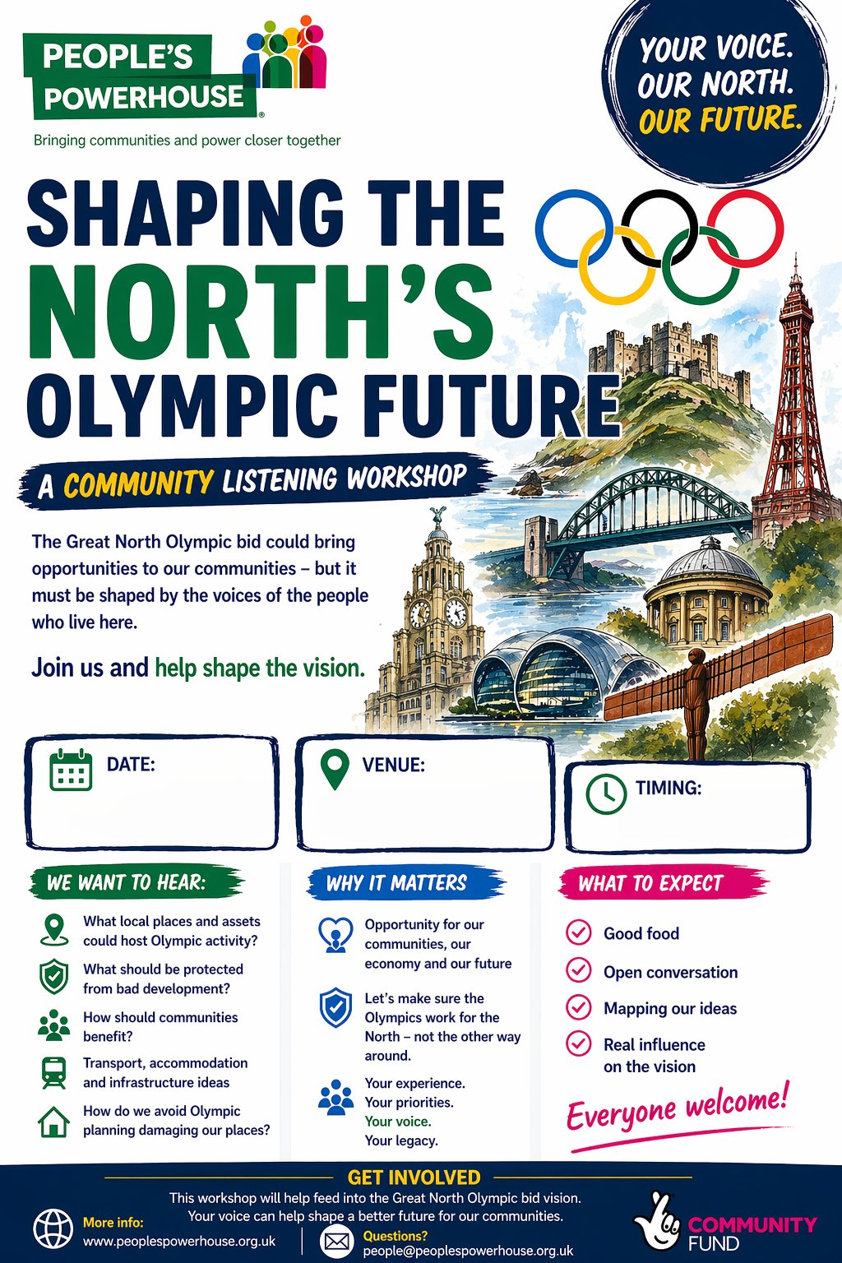

To book your place email Michelle.Redfern@northumberland.gov.uk by 15th May.
Alnwick Hub

Thurs 28th May
1pm – 3pm

