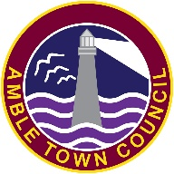

Accessibility Statement for Amble Town Council
Date: March 2026
We are committed to ensuring digital accessibility for people with disabilities. This accessibility statement outlines the measures we take to ensure accessibility of www.amble.gov.uk

Compliance Status
We strive to comply with the Web Content Accessibility Guidelines (WCAG) 2.2 AA standards. As of 7 March 2026 our website is compliant.
While we endeavour to maintain accessibility, some areas may not be fully accessible:
- Some PDF documents may not be compliant with accessibility standards.

Alternative Formats
If you require content in an alternative format please contact us at:
- Email: ask@amble.gov.uk
- Phone: 01665714695

Feedback
We welcome your feedback on the accessibility of our website:
- Is there anything you find challenging?
- Do you have suggestions for improvement?
You can reach us at ask@amble.gov.uk or 01665714695

Review and Updates
This statement will be reviewed and updated regularly. The next review is scheduled for March 2027.

