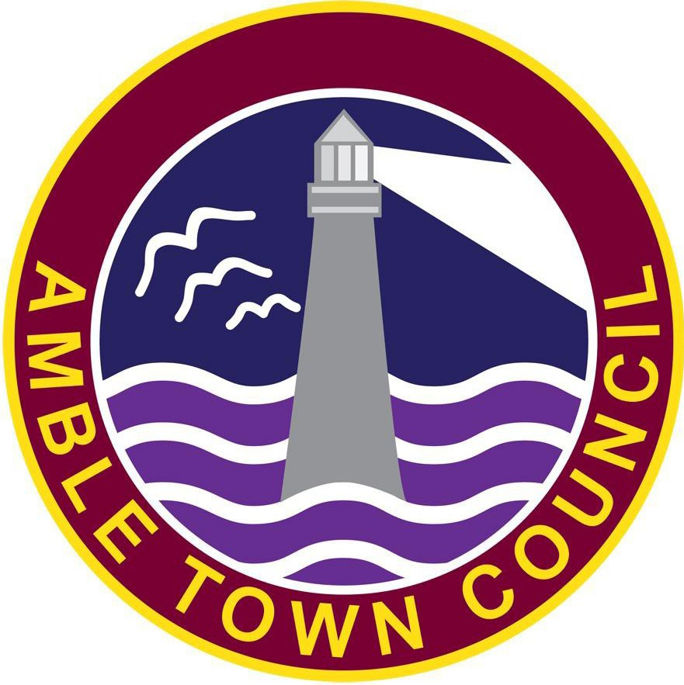
AMBLE TOWN COUNCIL
NAME | ADDRESS | TELEPHONE | EMAIL
OFFICERS
Mrs Vicki Smith Town Clerk | Amble Town Council, Fourways 2, 6 Dilston Terrace, Amble, NE65 0DT | 01665 714695 | townclerk@amble.gov.uk
Miss Suzanne Moore Admin Assistant | Amble Town Council, Fourways 2, 6 Dilston Terrace, Amble, NE65 0DT | 01665 714695 | admin@amble.gov.uk
Mrs Sue Fletcher  Admin Assistant | Amble Town Council, Fourways 2, 6 Dilston Terrace, Amble, NE65 0DT | 01665 714695 | ask@amble.gov.uk
EAST WARD
Cllr. Jenny Richards | Amble Town Council,  Fourways 2, 6 Dilston Terrace,  Amble, NE65 0DT | 07956308815 | Jenny.Richards@amble.gov.uk
Cllr. Ciara Dawson | Amble Town Council,  Fourways 2, 6 Dilston Terrace,  Amble, NE65 0DT | 01665714695 | Ciara.Dawson@amble.gov.uk
Cllr. Tony Regan | Amble Town Council,  Fourways 2, 6 Dilston Terrace,  Amble, NE65 0DT | 01665714695 | Tony.Regan@amble.gov.uk
CENTRAL WARD
Cllr. Kath MacColl | Amble Town Council,  Fourways 2, 6 Dilston Terrace,  Amble, NE65 0DT | 07525713086 | Kath.MacColl@amble.gov.uk
Cllr. Michael Joyce | Amble Town Council,  Fourways 2, 6 Dilston Terrace,  Amble, NE65 0DT | 01665714695 | Michael.Joyce@amble.gov.uk
WEST WARD
Cllr. Claire Connolly | Amble Town Council,  Fourways 2, 6 Dilston Terrace,  Amble, NE65 0DT | 01665714695 | Claire.Connolly@amble.gov.uk
Cllr. Ivor Rackham | Amble Town Council,  Fourways 2, 6 Dilston Terrace,  Amble, NE65 0DT | 01665 798435 | Ivor.Rackham@amble.gov.uk
Cllr Luke McTaggart | Amble Town Council,  Fourways 2, 6 Dilston Terrace,  Amble, NE65 0DT | 01665714695 | Luke.McTaggart@amble.gov.uk
COUNTY COUNCILLORS
Cllr Arty Hume | County Hall, Morpeth Northumberland,  NE61 2EF. | 07889143949 | Arty.Hume@northumberland.gov.uk
Cllr. Pauline Davidson | County Hall, Morpeth Northumberland,  NE61 2EF. | 07889143980 | Pauline.Davidson@northumberland.gov.uk
PRINCIPAL AUTHORITY
Northumberland County Council | County Hall, Morpeth, Northumberland, NE61 2EF | 0345 600 6400
MEMBER OF PARLIMENT
David Smith | 13 Telford Court, Morpeth, NE61 2DB / Berwick Workspace, 90 Marygate, Berwick Upon Tweed | 01670704099 | david.smith.mp@parliament.uk

