Free tree giveaway

Stakeholder toolkit

Contact
Kimberley Waugh
Media and communications officer
Kimberley.waugh@northumberland.gov.uk
07973901070
Included in this toolkit:
- Key messages
- Press release and photo
- Website copy
- Newsletter copy
- Suggested social media posts
- A4 poster
- TV screen advert
- Email signature

Key messages
- Northumberland County Council is giving away 10,000 trees.
- Applications are open to:
  - Residents
  - Community/voluntary groups
  - Town and Parish Councils
  - Schools/colleges
  - Landowners
  - Businesses
  - Charities
- Trees are great carbon absorbers which means that planting more trees can help Northumberland towards becoming a carbon neutral county by 2030.
- Tree planting is an opportunity for communities to come together, learn new skills and get outdoors.
- All ages and abilities can get involved.
- Help make Northumberland and cleaner and greener place to be.
- Help Northumberland grow.

Press release
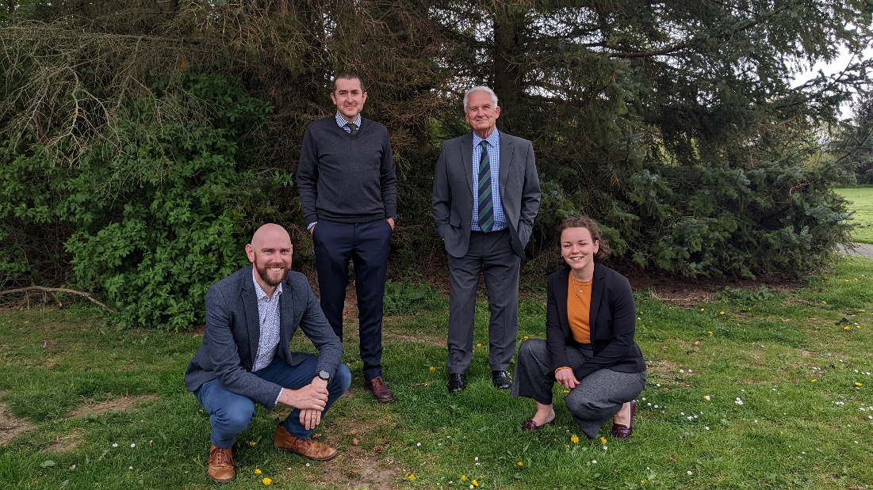

Grab yourself a free tree
Northumberland County Council’s free tree giveaway is back for another year.
The Council is offering 10,000 tree saplings to residents, schools, community groups, town and parish councils as well as charities and businesses to help make Northumberland a greener and cleaner place to be.
Eight different sapling species are on offer, which are suitable for small, medium, and large green spaces - even those with limited space can apply.
Council leader, Glen Sanderson, said: “It is fantastic to be able to offer thousands of free trees across Northumberland for a third year in a row. Last year the scheme was hugely popular so if you are considering planting a tree this winter, I would encourage you to apply sooner rather than later so that you do not miss out!”
Saplings for individuals and packs of up to 120 saplings for groups are now available to order online at https://tree-scheme.northumberland.gov.uk/SelfService. There will be a number of collection points and confirmation of your collection point will be sent out to you three weeks prior to the collection date.
Cllr Sanderson added: “The free tree scheme is a wonderful opportunity for communities to come together, learn new skills and get outdoors. All ages and abilities can get involved to plant and care for a tree. Taking up the offer will also help us reach our carbon neutral target by 2030, as trees are brilliant carbon absorbers."
The trees are small cell grown plants, sourced from the UK, and come provided with a biodegradable shelter guard, cane and planting and aftercare instructions.
To find out more about what Northumberland County Council is doing to tackle climate change, please visit www.northumberland.gov.uk/climatechange.
ENDS

Website copy
Grab yourself a free tree from Northumberland County Council
The council is giving away up to 10,000 free tree saplings help make Northumberland a greener and cleaner place to be.
Eight different sapling species are now available to order online, which are suitable for small, medium, and large green spaces - even those with limited space can apply including:
- Residents
- Community/voluntary groups
- Schools/colleges
- Town and Parish Councils
- Landowners
- Businesses
- Charities
As well as being good for the environment, planting trees is an opportunity for all ages and abilities within the community to come together, learn new skills and get outdoors.
The trees are small cell grown plants, sourced from the UK, and come provided with a biodegradable shelter guard and cane along with planting and aftercare instructions.
Accessible collection points will be available across the county during November, December and January and details will be announced in the week commencing 4th October 2022.
Find out more and apply: https://nland.cc/freetreesapply

Newsletter copy
Northumberland County Council’s free tree giveaway is back
The Council is offering eight different sapling species which will help make Northumberland a greener and cleaner place to be. The saplings are suitable for small, medium, and large green spaces - even those with limited space can apply including:
- Residents
- Community/voluntary groups
- Schools/colleges
- Town and Parish Councils
- Landowners
- Businesses
- Charities
As well as being good for the environment, planting trees is an opportunity for communities to come together, learn new skills and get outdoors. All ages and abilities can get involved.
The trees will be provided with a biodegradable tree shelter guard and cane along with planting and care instructions.
Accessible collection points will be available across the county during November, December and January and details will be announced in the week commencing 4th October 2022.
Find out more and apply: https://tree-scheme.northumberland.gov.uk/SelfService/

Social media suggested posts
FB/Insta | 🌳GRAB A FREE TREE🌳  Want to help Northumberland grow? Northumberland is investing in 10,000 new trees for the county but needs your help to plant them!  Claim your free tree if you’re a 👇  School  Community group  Resident  Landowner  Business  Order yours NOW 👇👇👇  https://tree-scheme.northumberland.gov.uk/SelfService/  #helpNlandgrow #Northumberland #climatechange #environment #treeplanting #green  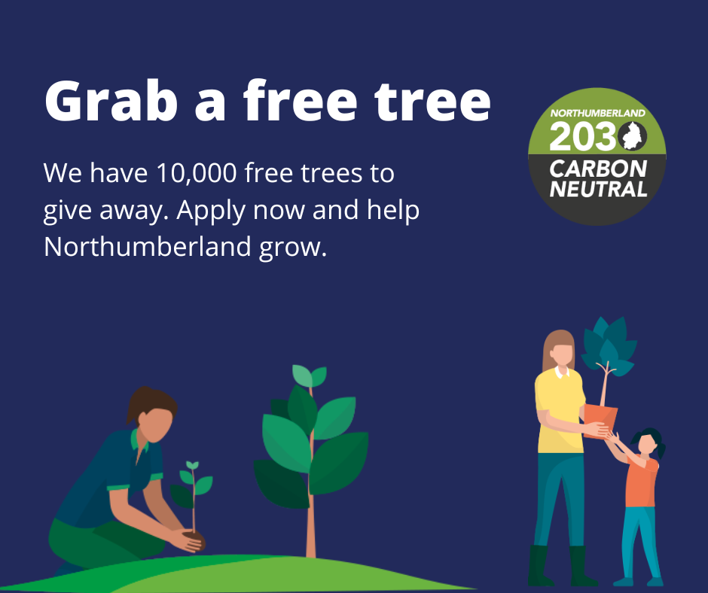
Twitter | 🌳GRAB A FREE TREE🌳  Want to #helpNlandgrow? @N_landcouncil is investing in 10,000 new trees for #Northumberland but needs your help to plant them!  Order yours NOW 👇👇👇  nland.cc/freetreesapply  #climatechange #environment #treeplanting #green  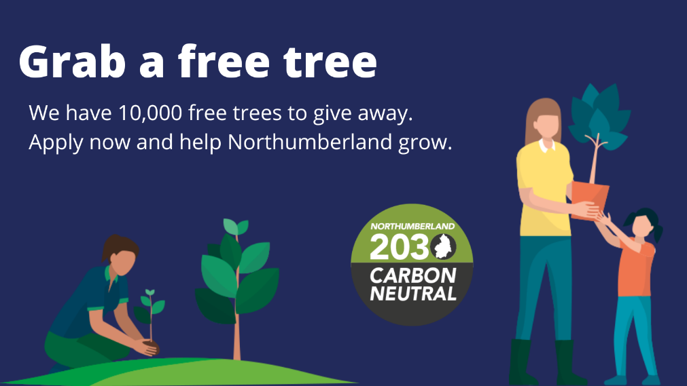
LinkedIn | 🌳GRAB A FREE TREE🌳  Want to help Northumberland grow? Northumberland County Council is investing in 10,000 new trees for the county but needs your help to plant them!  Claim your free tree if you’re a 👇  School  Community group  Resident  Business  Charity  Order yours today👇  nland.cc/freetreesapply  #helpNlandgrow #Northumberland #climatechange #environment #treeplanting #green

A4 poster
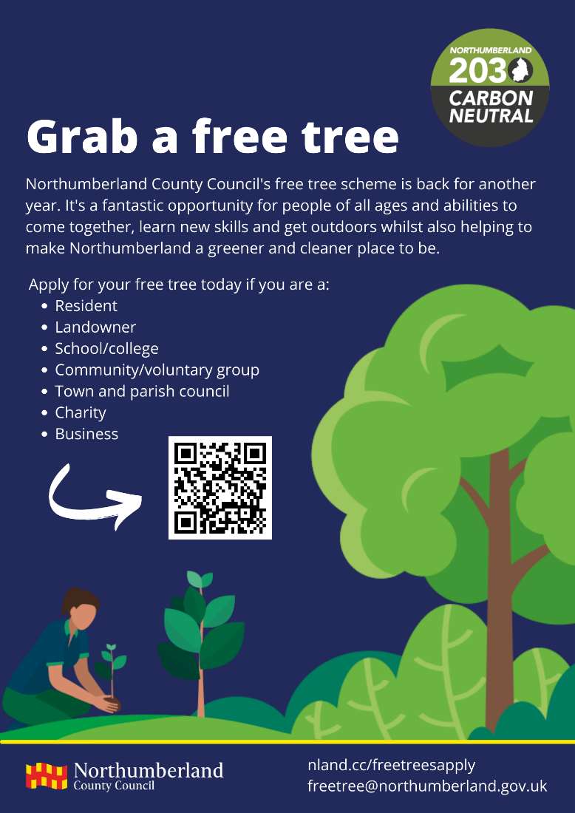

TV screen artwork
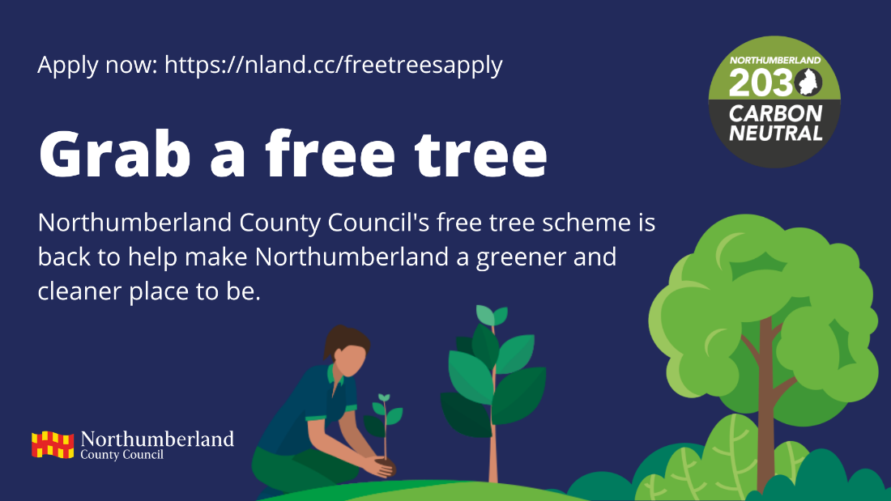
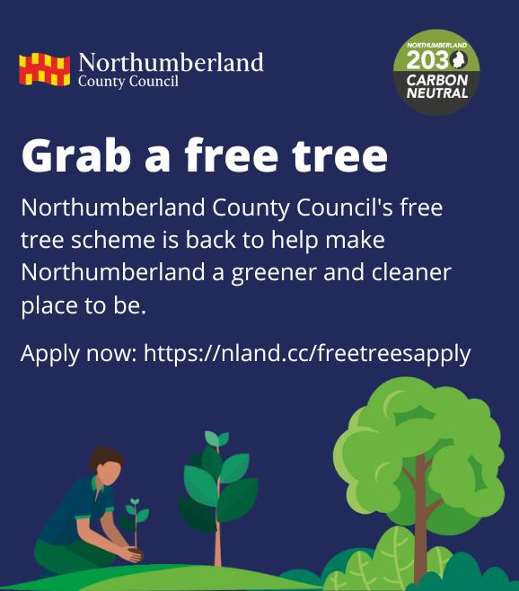

Email signature
