NEWSPAGE DRAFT- ISSUE DUE OUT BEGINNING OF DECEMBER
Town: 10th Dec; 14th Jan at 6p.m.
Amenities: 29th Jan at 6p.m.
Office: Closed from 3pm Wed. 23rd Dec to 10am Mon 4th Jan
SEASONS GREETINGS TO ALL
ONE WAY STREETS CONSULTATION
The experimental order will end in early Spring and so a decision needs to be made on whether it should be made permanent. It is vital that as many people as possible comment on this idea as, quite simply, public response is how decisions are made! Your opinion- whether for, against, or indifferent - needs to be expressed to NCC. We all acknowledge there were initial teething problems- as there always is with something new; some of these have been rectified, others cannot be altered until, and only if, the order is made a permanent feature. Please read the detail of the idea being proposed. The trial at present is trying to ease congestion and help traffic flow in those areas- a long standing problem for many years, especially at weekends and Bank Holidays, which affects everyone not just the people who live on those streets. Watch for press releases and notices appearing in the streets involved which will tell you how to respond. Details of the proposals will also be available to view by appointment in the Council offices.
AWARDS
GARDENS & ALLOTMENTS
There will be some chances to the Garden Awards in 2016. Commended, Highly Commended, Runner Up & Winner in each of the 3 wards of the parish will still be awarded with an overall Cup Winner for the best garden. However it has been decided that for any garden with the same resident(s) winning the Cup in any 3 of the previous 5 years, the resident(s) will be presented with a lifetime award in recognition of their continued high level of commitment and achievement and will no longer be entered for a further award. Individuals and Councillors can submit entries for the garden awards during the last 2 weeks of June. The 'Secret Garden' Award will continue for those gardens which would not normally be seen by a passerby. Entrants must agree to publicity and to opening their 'Secret Garden' for public viewing for a minimum of 3 hours during the second weekend of August. Entries can be submitted by individuals in the last 2 weeks of June, with contact details, either electronically as a photo attachment to an email or a photo delivered to the Council Office. There will be a Business Award with Winner and Runner Up to encourage individual businesses to make their frontage even more attractive. All gardens/ floral displays will be judged by an external independent person in the first 2 weeks of July for their visual effect, their general maintenance, the use of plants and materials and the physical input required in making and keeping the area attractive. The Best Allotment Award for each of the two areas of Allotments will stay as will Most Improved Allotment overall, to be judged by Amble Allotment Holders Committee in the last 2 weeks of June. Those shortlisted in all these categories will be invited to the Awards night later in July when the certificates and prizes will be presented.
COMMUNITY AWARD
Council have decided to introduce a new award which will be open to individuals as well as groups and organisations, any of whom are carrying out unpaid community work on a project or initiative. Nominations will be invited from the community during June, stating the name(s), what is being done, how long for, what benefit this brings to the community and why that individual/ group/ organisation deserves special recognition. Entries will be judged by a panel of Councillors early in July with those individuals nominated, or 2 representatives if a group or organisation, invited to the Awards night later in July.
LOCAL TRANSPORT PRIORITIES
Councils were recently asked to submit 3 items for the Local Transport Priorities. There is a sum of money allocated each year by NCC for these; all the proposals from every parish are put forward and assessed as to which should be carried out in that financial year. Of course, every parish thinks their items should be done first but the money only goes so far and inevitably some considered less urgent can be waiting for years. Every year one of the main topics we hear about from everyone is traffic and parking problems, so this year two of our priorities relate to these. We have said that a major review of the traffic & tourism signs in our town needs to be carried out as some signs direct you wrongly and others don't even exist! For example, there are few signs pointing to the places where you can actually park so it's no wonder people try to squeeze into small or inappropriate spaces. Despite being an old town with limited land available in the centre of the town, we desperately need a new Car Park. Whilst we have been working closely with NCC Officers regarding various aspects of the traffic problems in the town, progress on this matter is very slow. We are urging County to give this some serious consideration to find a way forward in the near future. Although our side streets aren't as bad as some towns, Bisley Road is in dire need of repair so we have made this our third priority.
WEST CEMETERY
So that the cemetery can be maintained properly, no kerbs or enclosures of any type are permitted in the newer sections. Floral tributes and small plants must not extend beyond 39cm (15") from the rear of the memorial in any section, except the Natural Burial area where none are allowed. This is so the grave plot can be more easily cut with our machinery. The immediate area around any headstone which does not have floral tributes or plants will be treated to avoid unsightly growth of weeds. This cemetery, which is open to the public, cannot be effectively secured therefore before placing any items on a grave owners should consider their distress if these items are damaged or stolen. Please do not place any unauthorised items, especially of a breakable nature, as these can pose a safety risk to the operatives as illustrated. Please check the rules first as unauthorised items will be removed but can be claimed up to 28 days before disposal.
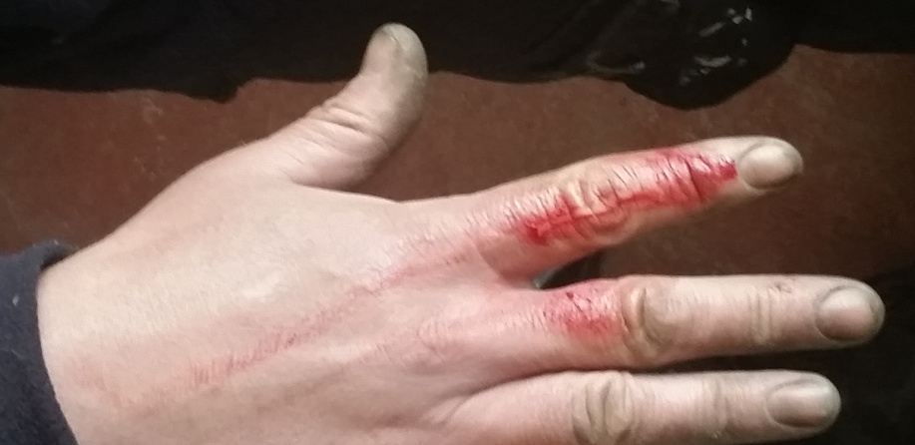
COUNCILLOR'S CORNER
It has been incredibly heartening for the town to be shortlisted for the Great British High Street Awards. I see this as testimony to how much the town has grown in recent years in terms of community involvement, team effort and pride in our town. The judges were escorted around the town to see what we have to offer and met some of the voluntary groups and businesses who work so hard to make Amble worthy of this recognition. I think we can all be very proud of this achievement.
This season it is really uplifting to see Amble’s preparations for the Christmas festivities. You may have seen our Christmas Lights team scaling ladders around the town centre to create the usual blaze of lights and been a part of the spectacular torchlit procession. Much planning has gone into celebrating the very first Christmas for the Harbour Village which will be aglow with sparkling lights, festive Pods and a very unique Christmas tree. None of this could happen without the huge effort of volunteers and our usual community spirit.
Vice Chair: Councillor Jane Dargue

