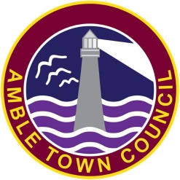

The Secret Garden Awards 2016

Many people tell us of wonderful gardens which are 'hidden' behind houses or fences and not usually seen by those passing by. You are now invited to nominate these 'secret gardens' by submitting a photograph to be judged.

Criteria:

- Visual Effect - the overall look and appeal
- General Maintenance - weeding, edging etc.
- Use of Plants and Materials- variety of plants/ containers/ objects; their position; how they complement each other
- Physical Input- the work involved in making and keeping the area attractive

Judging:

The judging will be done by a panel of 3 councillors.

Entries to be by photograph to Amble Town Council offices or via email on ask@amble.gov.uk

Rules:
The garden must not be usually accessible to the public.
Applicants must agree to open the garden for a period of 3 hours on a weekend in late July / early August – the date will be confirmed on the 12 July 2016
You must agree for your address to be made known by the media and to the public for the above viewing.
The judging panel may require access to those shortlisted in order to verify their accuracy.

If you wish to take donations for a charitable cause for refreshments on the viewing day you are welcome to do so.

Closing date for entries 30th June 2016.

